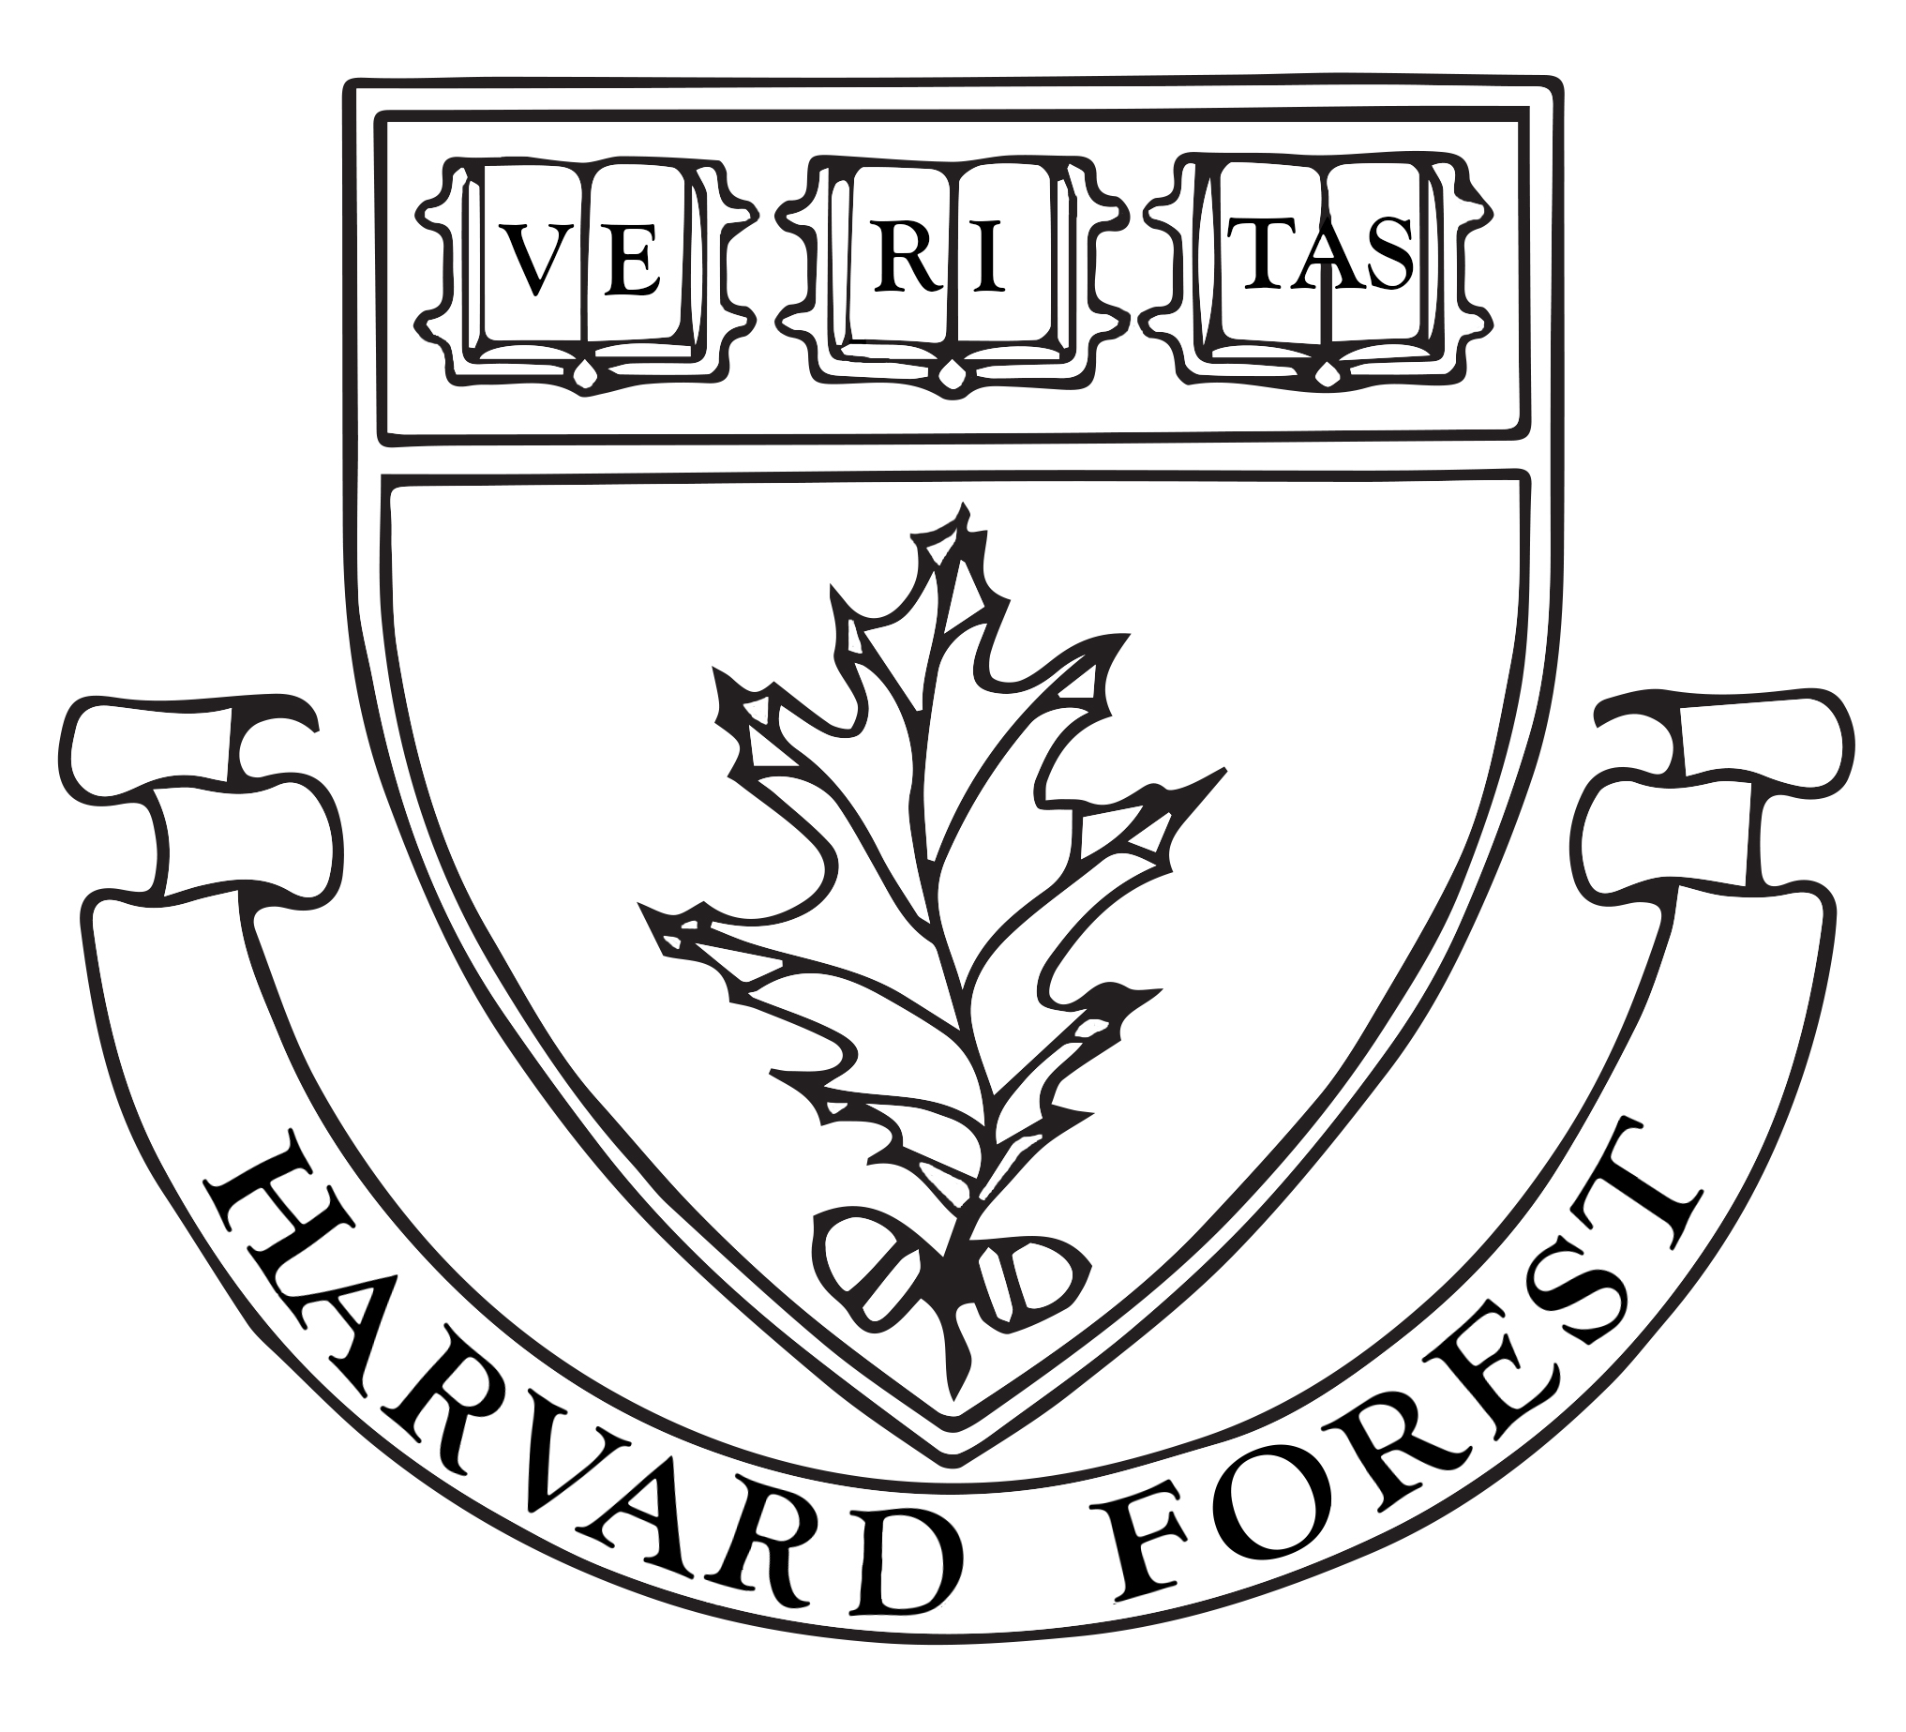
Harvard Forest Summer Research Program in Ecology
Application Deadline for all documents: Friday February 1, 2019, 9:00AM EST.

Application Checklist: To be considered complete, ALL applicants must submit the following via the online application system (EMAIL ATTACHMENTS WILL NOT BE ACCEPTED):
- 2 Letters of Recommendation: It is strongly suggested that the 2 referees information including email addresses be entered as soon as possible to allow referees appropriate time to complete their letters.
Referees will not be able to submit a letter of recommendation until you have filled their contact information out on the application.
    - Enter email and phone contact information for the two recommendation providers. You must enter all the information for your referee at that time, as it cannot be edited.
    - ONCE you have entered a referee's email address and press the “Notify Referee” button, an email from hfweb@fas.harvard.edu will be automatically sent to the referee with instructions on how to submit the reference on-line. ONLY the references listed can submit a letter for you.
    - Let your referee know that he/she will receive an email from hfweb@fas.harvard.edu and to check spam and/or junk filters.
- Resume: (upload as attachment) – DO NOT include transcripts.
- Project Choices: choose up to 4 project choices from the list provided in the order of preference.
- Essay: describing your career objectives, science background (including relevant courses, employment, or experiences), expectations for a successful summer experience, and your educational and career objectives (250 words maximum – upload as attachment)
Hints & Tips:
- Please note that we can support only 5-7% of students who apply to this program. In a typical summer, we receive 400+ applications for 25 spots. The most competitive applications are those in which the application essay reflects careful consideration of how the program and the research projects dovetail with your educational and career goals.
- The best applicants spend time perusing the Forest web site and craft a thoughtful essay about their individual interests, why they have picked the projects listed, why the Forest in particular interests them and how this internship program will help them further develop their career goals.
- You will be notified by email upon submission of your application and after each recommendation is submitted, and you can check your application status by going to: http://harvardforest2.fas.harvard.edu/asp/hf/php/login.php?context=reu_review.
Official Notification of Acceptance/Rejection will be made on March 4, 2019.

For Additional Information: see FAQ section; e-mail hfapps@fas.harvard.edu.
NOTE: If you are having trouble uploading an attachment, please contact hfweb@fas.harvard.edu. Attachments sent via email will not be accepted/considered.

