Tree Leaf Terminology _________________________________
Circle the features Name block

Leaf A __________________________

Compound/Simple Lobed/Entire Toothed/Smooth/Wavy Palmate/Pinnate veins Oval/Fan-shaped

Leaf B __________________________

Compound/Simple Lobed/Entire Toothed/Smooth/Wavy Palmate/Pinnate veins Oval/Fan-shaped

Leaf C __________________________

Compound/Simple Lobed/Entire Toothed/Smooth/Wavy Palmate/Pinnate veins Oval/Fan-shaped

Leaf D __________________________ (btw, that’s a whole branch of the leaves)

Compound/Simple Lobed/Entire Toothed/Smooth/Wavy Palmate/Pinnate veins Oval/Fan-shaped

Leaf E __________________________

Compound/Simple Lobed/Entire Toothed/Smooth/Wavy Palmate/Pinnate veins Oval/Fan-shaped

- Basic structure
  - Leaf is compound - - - - - - - - - - Hickory
  - Leaf is simple - - - - - - - - - - - - - go to 2
- Edge
  - Edge is lobed - - - - - - - - - - - - - go to 3
  - Edge is entire - - - - - - - - - - - - - go to 4
- Veins
  - Palmate veins - - - - - - - - - - - - - Maple
  - Pinnate veins - - - - - - - - - - - - - - Oak
- Margin
  - Margin is smooth - - - - - - - - - - - a whole branch of those maddeningly oval leaves = MOL
(maybe an Osage Orange or just some generic leaves that an artist drew without really knowing)
  - Margin is wavy - - - - - - - - - - - - go to 5
- Shape
  - Fan shaped, including the veins - - - Gingko
Tree Leaf Terminology - Leaf drawings
A:↗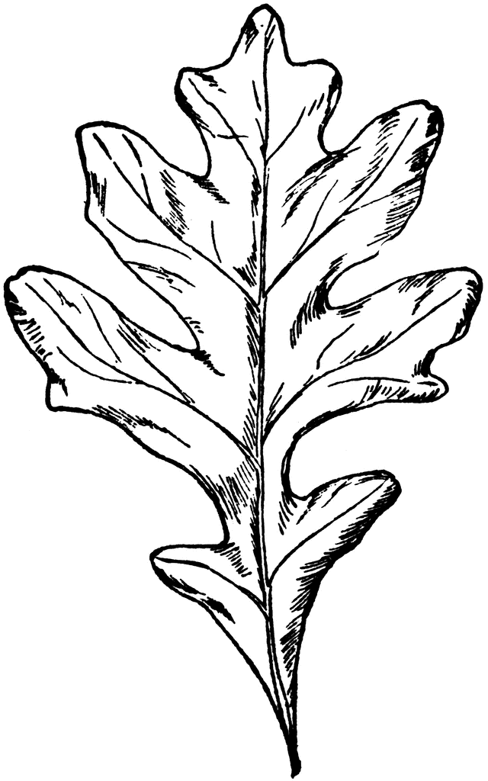 B:↗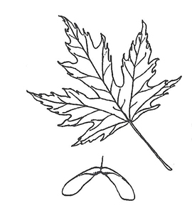
C:↗ 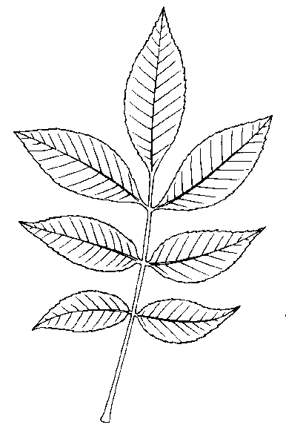D:↗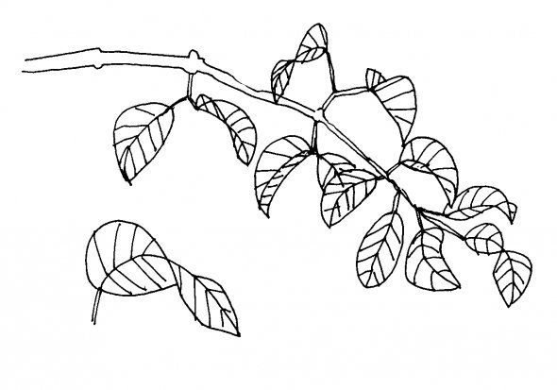
E:↗ 