Study Branch Photos: Williston School Northampton April 17, 2020 by Jane Lucia
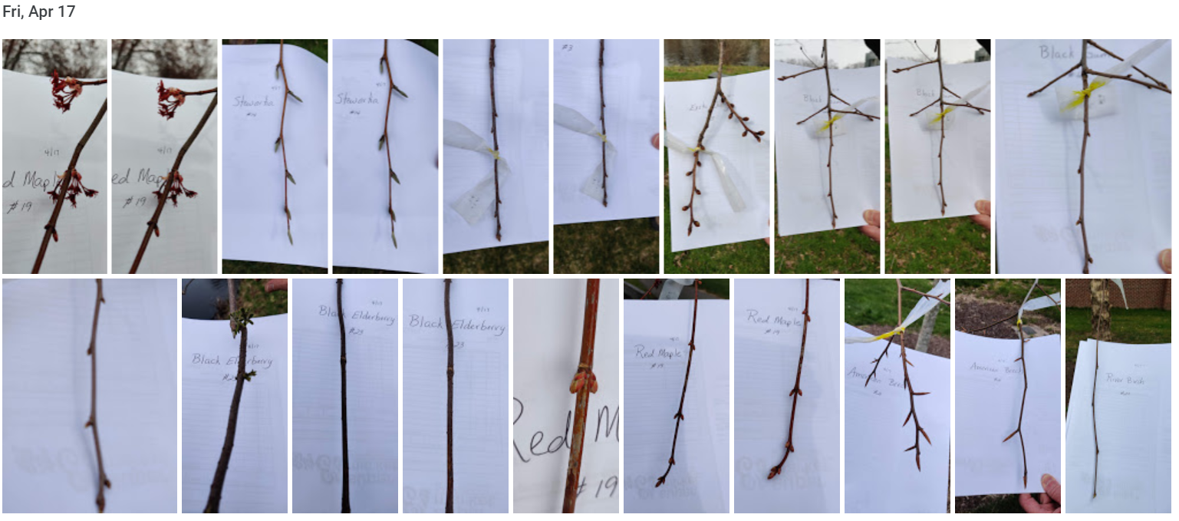
Note from Jane:
I was able to get over to school today and took some pictures. Access them on Google at: https://photos.app.goo.gl/Tq4JcqfZ3XKf25zY7
The white paper background was so helpful for focusing and seeing the buds. I also recorded the 6 buds for each tree on data sheets. I will make an effort to get out a few more times to capture leaf out as best as possible. I am also sharing this link with my students for observation, though I only took photos of one of the branches on each tree.

See the following page for close ups of 3 photos for reference.
