Explore Harvard Forest Buds Data: Distance Learning Alternative

  - Go to Harvard Forest (HF) website using this link: https://harvardforest.fas.harvard.edu/schoolyard/phenology-data
  - Click on "Graph Data"
  - Follow the prompts and submit on each screen;
- Fall Phenology
- Detailed data from a single site
- Select Williston Northampton School from the dropdown menu
- Submit again (WNM-Buds-001) do not fill in any dates

You will get a list of trees from our site to choose from:

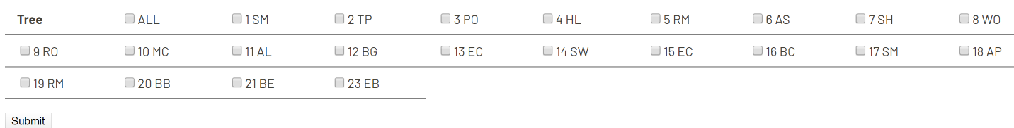

I have marked the trees that are currently part of our research study. Please select your tree number, plus two other trees in our current site, for comparison. Then Submit.

d. On the next screen, click on the green "Growing Season". This will bring up a graph in a new window.
- Look at the graph carefully to see what it is showing you. If you want to see a graph with some other trees, select the previous tab at the top of your browser to go back.
- When you have a graph you want to write about, take a screen clipping of the graph and paste it onto the "Harvard Forest Data Graphs" page in the Talking Tree tab.

- Interpret the graph that includes your tree. The following questions can be used to help you begin to think about the graph you are looking at.
  - How long is the growing season for your tree? Has it been the same every year?
  - How does it compare to the other trees?
  - Do you see a trend in the lengths of the growing seasons over the years shown on the graph?
Write a paragraph to express your thinking. (A sample graph and paragraph is located in the CL/Talking Trees tab.)

The following is a tree species key for your convenience. Please use the tree names when referring to specific data in your writing.

PO= pin oak
BG= Black Gum
EC= exotic cherry
SW= Stewartia
RM= red maple
BB= black birch (really a river birch!)
BE= Beech
EB= black elderberry

