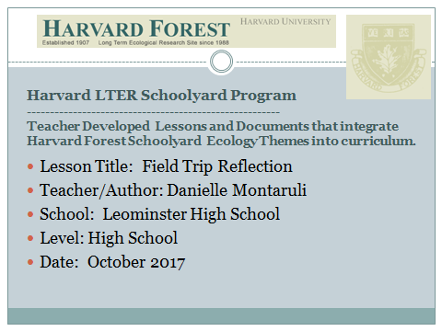
Part 1: Dioramas (7 dioramas-10 pts each + 10 pts discussion = 80 pts)
- Take a picture of each diorama
- Arrange the dioramas in chronological order with a brief description of each. You need to include (each diorama should be on a separate page)
  - What is happening in each diorama
  - What the dominant form of life is in each
  - How the landscape has changed
  - What the timber was being used for or how the land was being used
  - To what extent was the land use sustainable
- Discussion: Give a general synopsis of how the land has changed over the years, the type of succession going on, and to what extent the forest returned to its natural, undisturbed state.
- For additional information, http://harvardforest.fas.harvard.edu/dioramas, gives a picture of each diorama with a brief description of each.
Part 2: Harvard Forest Ecosystem Walk (60 pts/ 20pts per section)
- Discuss one of the studies going on. What is the problem and how is the information and data being obtained?
- Identify at least 10 organisms and explain their importance to the ecosystem, and their importance to each other, if a relationship exists. Create a food web, if possible.
- Woolly Adelgid
  - What is it?
  - What is it affecting and how?
  - How it got to New England
  - Steps, if any, being taken to eradicate it and why that method is being chosen.

Part 3: Overall Field Trip Experience (10 pts)
- What did you like most about the field trip? Least?
- What did you find most interesting?
- Are there any lingering questions that you didn’t ask or thought of after the fact that you wish you had an answer to?

Due: (150 pts total)

